SECTION A
MULTIPLE CHOICE QUESTIONS (20 MARKS)
(INSTRUCTION: Please answer all 20 questions in the answer sheet on page 16)
1) | The following statements are TRUE for segmented memory allocation EXCEPT:
 | A) | Main memory now allocated dynamically
 | B) | Segments are same sizes.
 | C) | Needs segment table.
 | D) | Difficulty managing variable-length segments in secondary storage.

2) | What does segment-table length register (STLR) indicates?
 | A) | Points to the segment table’s location in memory.
 | B) | Number of pages used by a program.
 | C) | Number of segments used by a program.
 | D) | Points to the page table’s location in memory.

3) | Choose FALSE statement about virtual memory
 | A) | It enables only part of a program to be in memory for execution.
 | B) | Logical address space can be much larger than physical address space.
 | C) | It allows address spaces to be shared by several processes.
 | D) | It causes inefficient process creation.
4) | Demand paging for virtual memory has the following benefits when bringing a page into memory EXCEPT:
 | A) | Less I/O needed
 | B) | Less memory needed
 | C) | Slower response
 | D) | More users.

5) | Based on segmentation in Figure 1, identify the correct values for X and Y.  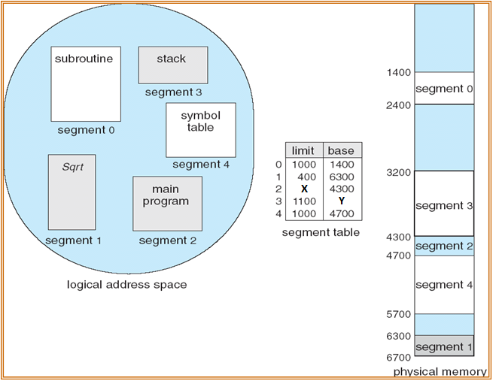  Figure 1: Segmentation
 | A) | X=400, Y=3200
 | B) | X=3200, Y=200
 | C) | X=200, Y=200
 | D) | X=3200, Y=3200

6) | Which of the following statement is TRUE regarding page replacement?
 | A) | Modify bit 1 indicates page has not been modified, while modify bit 0 indicates page has been modified.
 | B) | It is executed when page faults occurs
 | C) | It is executed when free frames are available in physical memory.
 | D) | If there is no free frame, use the page on disk.

7) | Current content of page table for a virtual memory is shown in Figure 2. Accessing the following frames is valid EXCEPT:  0  0 A 1  1 T 2  2 L 0 3 v 3 A  3 R 1 i 4  4 I 2 6 v 5  5 Y 3 8 v 6 L  6 Z 4 i 7  logical page table 8 I  memory 9  Figure 2: Page table physical memory
 |  | A) | 3
 |  | B) | 6
 |  | C) | 8
 |  | D) | 9

8) | Which of the following event DOES NOT contribute to thrashing?
 | A) | If CPU utilization is low; OS increase the degree of multiprogramming.
 | B) | The number of programs increases while the number of frames remains the same.
 | C) | Page fault occurs more frequently as the degree of multiprogramming increases.
 | D) | A process spends more time on executing than paging.

9) | The following are file attributes EXCEPT:
 | A) | name.
 | B) | type.
 | C) | size.
 | D) | database.
10) | What is the level for directory as shown in Figure 3?  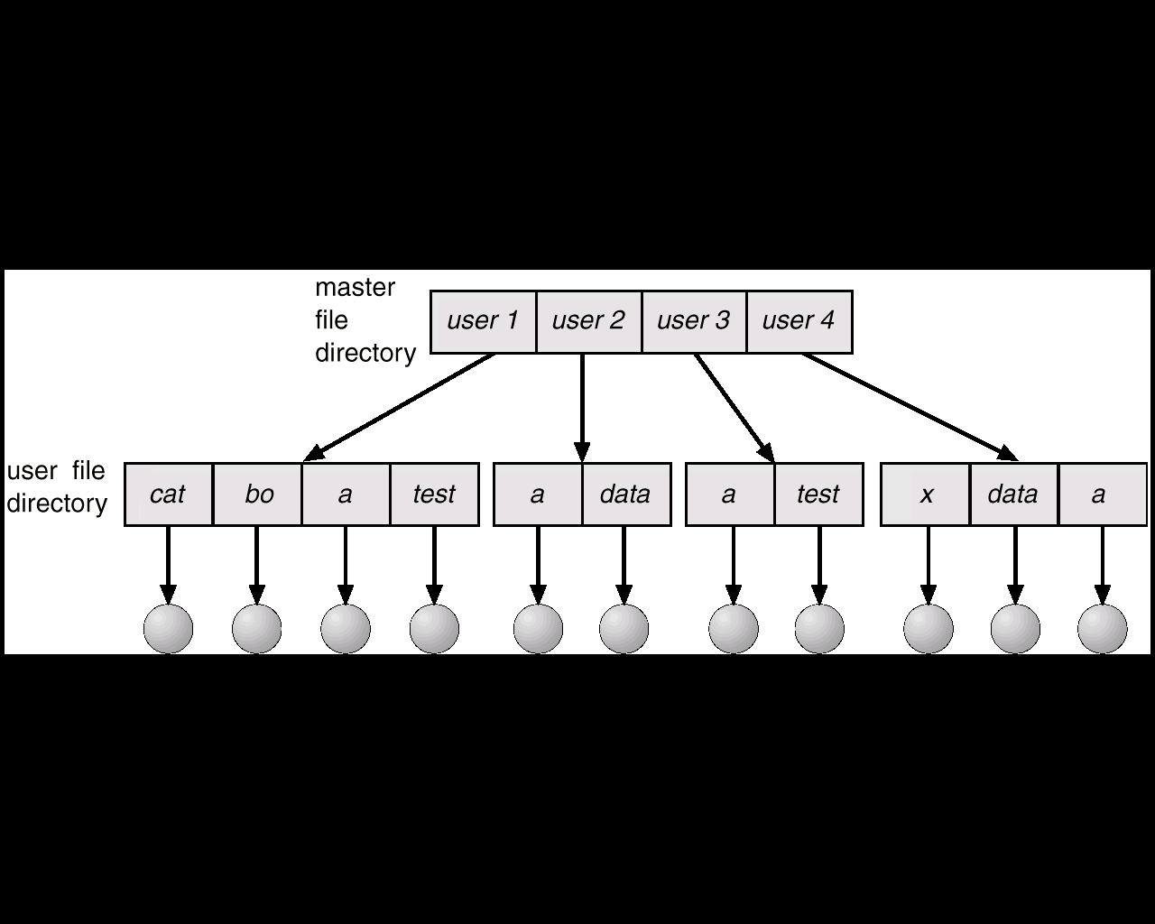  Figure 3: File structure
 | A) | 2
 | B) | 4
 | C) | 11
 | D) | 16

11) | The following file name convention begins at the root and follows a path down to the specified file.
 | A) | type filename
 | B) | extension filename
 | C) | absolute filename
 | D) | directory filename
12) | The following are file extensions EXCEPT:
 | A) | .file
 | B) | .exe
 | C) | .mp3
 | D) | .obj

13) | Access control list for files and directory in UNIX is classifieds in three (3) classes EXCEPT:
 | A) | owner
 | B) | admin
 | C) | group
 | D) | public/universe
14) | What is the size of bit map for a disk with a block size equals to 2²⁰ bytes and the disk size is 4 Gigabyte.
 | A) | 1024 bytes
 | B) | 512 bytes
 | C) | 2¹² bytes
 | D) | 2²⁰ bytes

15) | What is the technique of free disk space management that employs a pointer from the current free block to the next free block?
 | A) | Bit map
 | B) | FAT
 | C) | Linked list
 | D) | NTFS

15) | One of the primary advantages of using linked list grouping in memory management technique is:
 | A) |  | Can be used effectively for free space management.
 | B) |  | Multiple programs can run at the same time.
 | C) |  | I/O is used more efficiently.
 | D) |  | CPU is used based processor scheduling algorithm.
17) | Total access time is given as A = B + C + D. If B is the transfer time of the data and C is the seek time of the disk head required to move to a particular cylinder, what is D?
 | A) |  | Outermost time
 | B) |  | Rotational delay
 | C) |  | Track time
 | D) |  | Cylinder time

18) | What is the main similarity between C-SCAN and C-LOOK disk scheduling algorithms?
 | A) | Both schemes have no directional bit.
 | B) | Both schemes have directional bit.
 | C) | Both schemes aims to increase data transfer time.
 | D) | Both schemes aims for reducing data file size.
19) | Which level of RAID is described by these statements?  • Data striping is used, without mirroring  • No error correction/redundancy/recovery is applied
 | A) | Level 0
 | B) | Level 4
 | C) | Level 5
 | D) | Level 6

20) | Which level of RAID is described by these statements?  • Provides extra degree of error protection/correction  • Two different parity calculations (double parity)  • Parities stored on separate disk across array
 | A) | Level 0
 | B) | Level 1
 | C) | Level 2
 | D) | Level 6

SECTION B
STRUCTURED QUESTIONS (80 MARKS)
(INSTRUCTION: Please answer all questions in the answer booklet)

QUESTION 1 [25 Marks]
(a) | Answer the following questions based on the basic concepts of memory management for operating systems.  - The management of main memory is critical, thus the entire system performance is dependent on two (2) items/factors. Give the two (2) items/factors. [2]  - Describe the fundamental difference between logical address and physical address? [2]  - A process can be swapped temporarily out of memory to a backing store and then brought back into memory for continued execution. In the simplest term, what does backing store here refers to? [2]  - When a process is being swap out and another desired process is being swap in by the dispatcher for execution, what does it actually means? [2]  - Swapping to free up memory is constrained by some factors. Can a process waiting for I/O operation be swapped? Furthermore, what is the primary selection criterion to swap out a process? [2]
(b) | The following questions deals specifically with the fixed partitions memory scheme. As shown in Figure 4, there are nine (9) fixed partitions of different sizes, and there are several jobs waiting to be loaded into memory for execution.  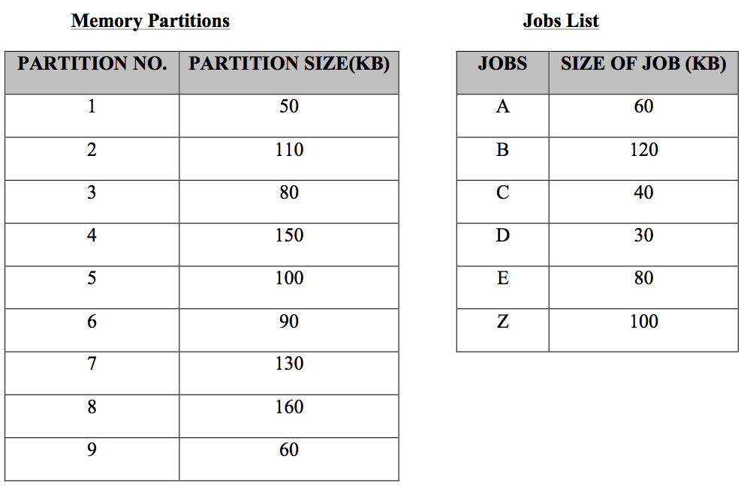  Figure 4: Jobs Allocation into Fixed Partitions  - How would the First-fit, Best-fit and Worst-fit algorithms place all the jobs into the memory partitions? [8]  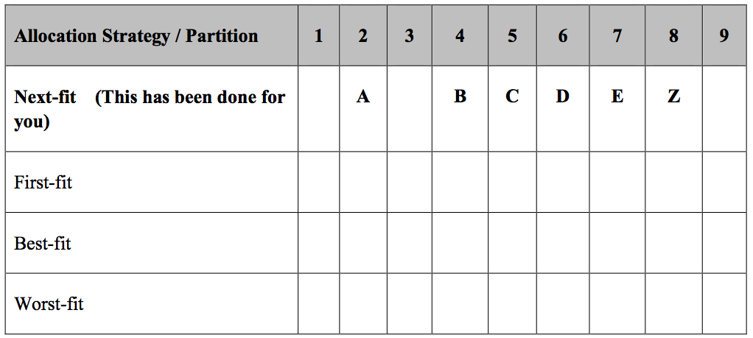  - Calculate the size of internal fragmentations incurred for each job and then compute the total size of fragmentation for First-fit and Best-fit job allocation schemes. [4]  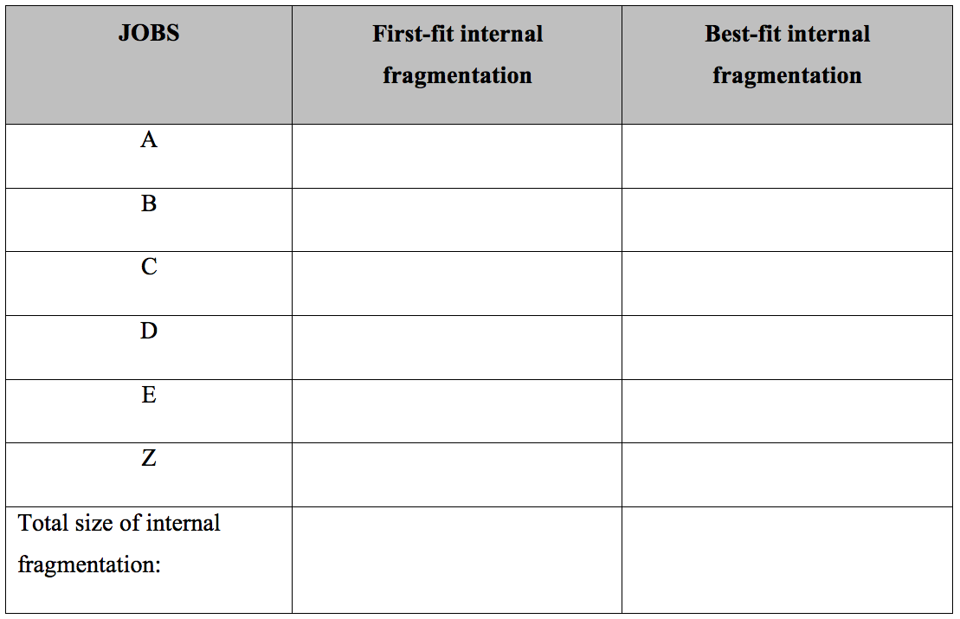  - For all the jobs allocation schemes above, is there any job that needs to wait from entering a partition? State the job and allocation scheme. [1]  - Rank all the three (3) jobs allocation schemes above (First-fit, Best-fit, Worst-fit) in terms of how efficiently they use memory. [2]  Rank 1:  Rank 2:  Rank 3:

QUESTION 2 [10 Marks]
(a) | State TRUE or FALSE for the following statements. [3].  Statements TRUE / FALSE  Paged memory allocation divides each incoming job into pages of equal size.  The disadvantage of paged memory is that it allows job allocation in non contiguous memory.  Page table consist of page number and corresponding page frame memory address.
(b) | Given a paging system with 2³² bytes of physical memory; 2¹⁰ pages of logical address space and page size of 4096 bytes. [7]  - What is the total size of the logical address space?  - What is the frame size of the physical memory?  - How many frames of the physical memory?  - How many number of entry in the page table?  - Calculate the offset bits for a page of virtual memory  - Draw the frame offset of the physical memory address and page offset of logical memory.

QUESTION 3 [15 Marks]

CPU is executing a loop for an array implementation and a series of memory locations are accessed repeatedly. Given the following reference string:
1 | 2 | 3 | 4 | 1 | 2 | 3 | 4 | 1 | 2

(a) |  |  | Apply LRU page replacement algorithm and calculate how many page faults will occur. Assume three (3) page frames are used. Show all your workings. [4]
LRU
Frame#1
Frame#2
Frame#3
Page faults

(b) |  |  | Apply OPT page replacement algorithm and calculate how many page faults will occur. Assume three (3) page frames are used. Show all your workings. [4]  OPT  Frame#1  Frame#2  Frame#3  Page faults
(c)  (d)  (e) |  |  | Which algorithm has the best performance in term of page faults occurred? Justify your answer. [1]  State 2 methods used in LRU implementation.  Does increasing the page frames to four (4) cause Belady’s anomaly effect on LRU? Justify your answer. [4]  Frame#1  Frame#2  Frame#3  Frame#4  Page faults
QUESTION 4 [10 Marks]

(a) |  | Arrange READ logical command statements in correct sequence when interacting with file manager. [2]  Statements Sequence  Wait for rotational delay (sector containing record passes under read/write head)  Send flag indicating free device for another request  Activate appropriate read/write head and read record  Transfer record to main memory  Move read/write heads to record cylinder 1
(b) |  | Indicate whether statements below are TRUE or FALSE according to the Unix files access control list as shown in Figure 5. [6]  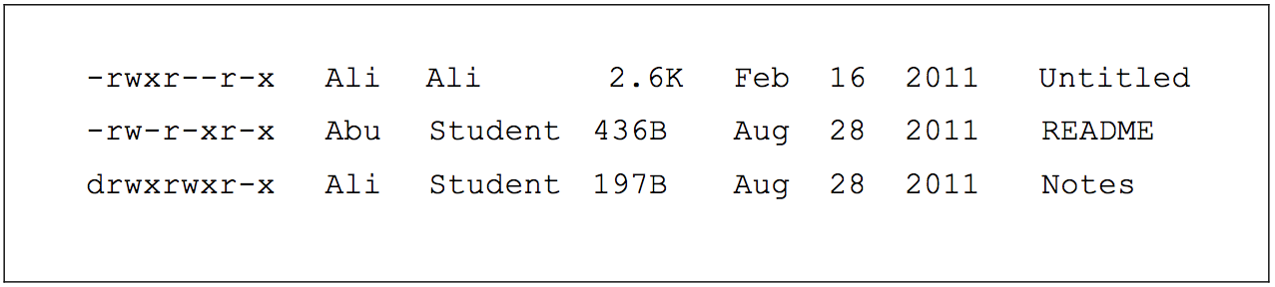  Figure 5: Unix file access control
 |  | i) |  |  |  | Untitled and README are directory.
 |  | ii)  iii)  iv)  v)  vi) |  |  |  | README group access right is read only.  Notes is a folder that is shared among Student group.  Owner of the README file is Student.  Untitled file can be edited by Ali.  README can be executed by public.
(c) | Figure 6 shows some output from file-system related commands on a local Linux system. Use this output and your knowledge of Linux file systems to answer the following questions. [2]  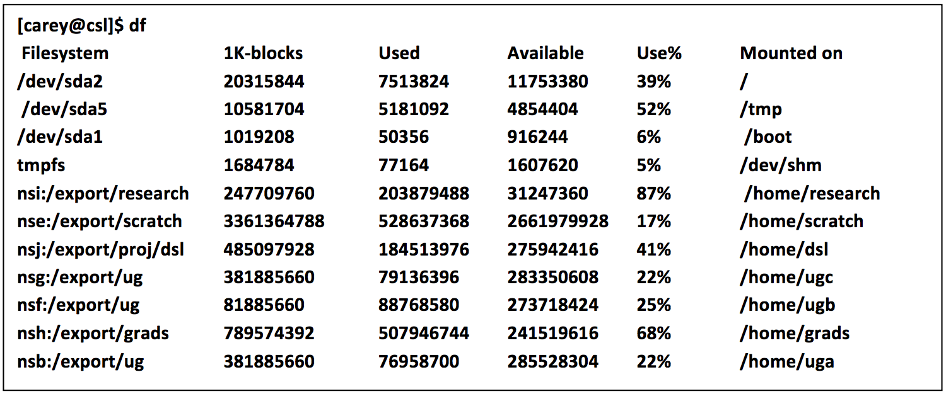  Figure 6: Unix file-system output
 | i) |  |  |  | How many different file systems are accessible on this Linux system?
 | ii) |  |  |  | Which file system is the fullest (in terms of percent occupancy)?
 | iii)  iv) |  |  |  | Which file system has the largest physical storage capacity?  Which file system has the fewest bytes currently stored?
QUESTION 5 [10 Marks]

Figure 7 shows a storage map of a disk. The disk has twenty (20) storage blocks and size of a storage block is 256KB. Two files will be stored in the storage disk are DATA1 and DATA2. Size of DATA1 is 718KB, while the size of DATA2 is 300KB.

Assuming the operating system is using Indexed Storage Allocation, each storage block can only store 4 block addresses.

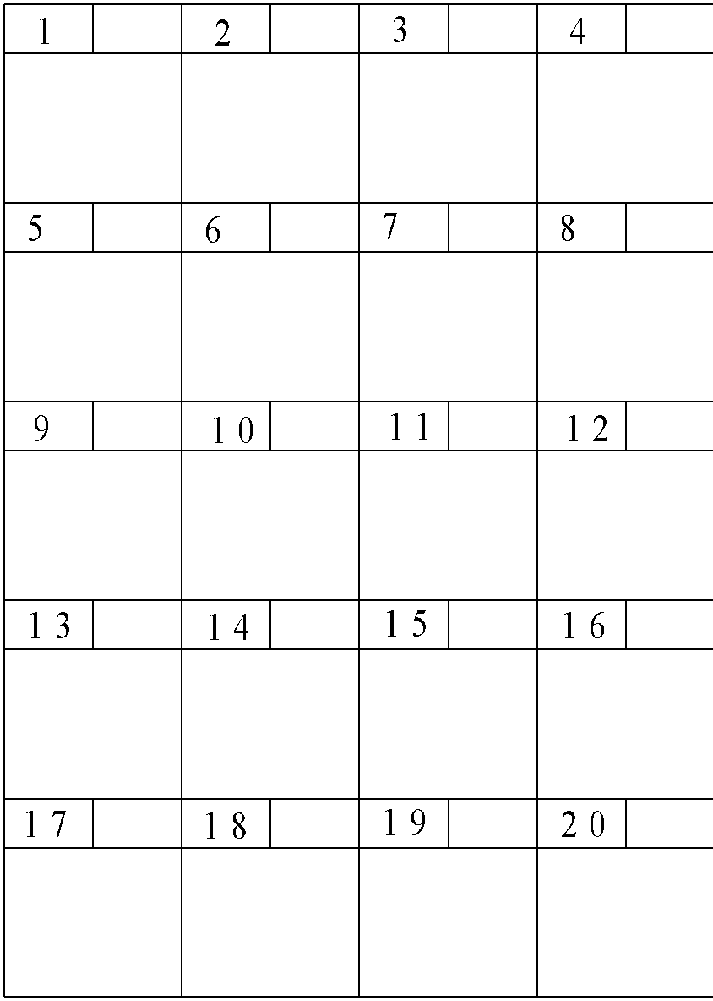  Figure 7: Storage Map | Filename File Size (KB) Index Block Number  DATA1 718  DATA2 300  Directory File

(a) |  |  |  | What is the maximum capacity of the disk? [2]
(b)  (c)  (d) |  |  |  | Fill in the Index Block Number column in Directory File and update the Storage Map accordingly for DATA1. Consider index block for DATA1 is block 6 and use blocks with the lowest number value for DATA1 storage map. [3]  Fill in the Index Block Number column in Directory File and update the Storage Map accordingly for DATA2. Consider Index block for DATA2 is block 16 and use blocks with the highest number value for DATA2 storage map. [3]  Is there any block that suffers from fragmentation in storing the DATA2 file?  If your answer is a YES, state the block number and calculate the size of fragmentation that incurred in the block. [2]

QUESTION 6 [10 Marks]

On a disk with 800 tracks: numbered from 0 to 799. The disk queue in FIFO contains the following track requests:
233, 75, 744, 300, 680, 190

Starting from the current head location 600, sketch figure to illustrate the head movement (track traveled) to serve all the requests based on:.

(a) | SSTF seek strategy. [4]
 | 0 75 190 233 300 600 680 744 799
(b)  (c) | C-SCAN seek strategy. The head movement direction is outer to inner. [4]  0 75 190 233 300 600 680 744 799  According to the above scenario in (a) and (b), which seek strategy is better between SSTF and C-SCAN? Briefly justify your answer. [2]  ANSWER SHEET FOR SECTION A  ANSWER SHEET FOR SECTION A  Name  Mertic No.  Lecturer (Circle) FIROZ, MAZURA, AHMAD FARIZ, NOH, ZURIAHATI, ISMAIL FAUZI, MOHD SOPERI, MAZNAH
Mark your answer clearly.
Example: =A= =B= =C= =D=

1. | =A= =B= =C= =D= |  | 11 | =A= =B= =C= =D=
2. | =A= =B= =C= =D= |  | 12. | =A= =B= =C= =D=
3. | =A= =B= =C= =D= |  | 13. | =A= =B= =C= =D=
4. | =A= =B= =C= =D= |  | 14. | =A= =B= =C= =D=
5. | =A= =B= =C= =D= |  | 15. | =A= =B= =C= =D=
6. | =A= =B= =C= =D= |  | 16. | =A= =B= =C= =D=
7. | =A= =B= =C= =D= |  | 17. | =A= =B= =C= =D=
8. | =A= =B= =C= =D= |  | 18. | =A= =B= =C= =D=
9. | =A= =B= =C= =D= |  | 19. | =A= =B= =C= =D=
10. | =A= =B= =C= =D= |  | 20. | =A= =B= =C= =D=

